**Corner tree branch bookshelf**

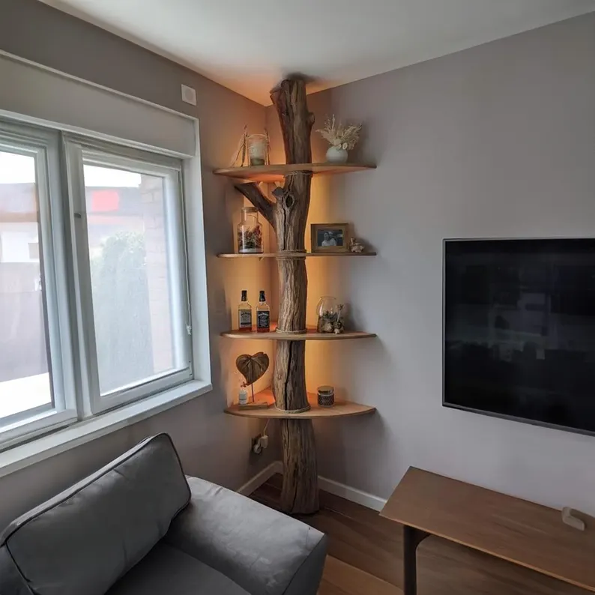A Corner Tree Branch Bookshelf is a unique and artistic shelving solution that combines nature-inspired design with functional storage. Often crafted from reclaimed wood or metal, this bookshelf mimics the organic shape of tree branches, creating a striking focal point in any room. Its corner design maximizes space while offering a creative way to display books, plants, or decorative items. Perfect for rustic, bohemian, or nature-themed interiors, the corner tree branch bookshelf brings an earthy, whimsical touch to your home while maintaining a sense of functionality. It’s a perfect blend of art and practicality for those looking to add a distinctive piece to their space.

.